**CHAPTER 1**

**INTRODUCTION**

In the era of digital transformation, recommendation systems have become a cornerstone of online platforms, influencing user choices and enhancing personalization. Whether it's streaming services, e-commerce platforms, or educational tools, the ability to offer tailored suggestions plays a crucial role in user satisfaction and engagement. This project delves into the creation of a **Movie Recommendation System (MRS)** designed to recommend movies based on user preferences, leveraging factors such as genres, cast, crew, and language.

The system is implemented using Python, which provides a comprehensive ecosystem of libraries and tools for data manipulation, machine learning, and algorithm development. By focusing on key attributes of movies, the project aims to develop an intelligent model capable of identifying patterns and suggesting movies that align with the user's interests.

This recommendation system is targeted for educational purposes, providing students and developers with a hands-on understanding of the inner workings of recommendation algorithms. It demonstrates how machine learning concepts can be applied to solve real-world problems, making it an ideal mini-project for aspiring engineers.

The project’s primary goal is not only to highlight the technical aspects of building a recommendation engine but also to explore how data-driven approaches can enhance decision-making processes. By integrating theoretical knowledge with practical implementation, this project bridges the gap between academic learning and real-world applications, fostering innovation and creativity in the field of artificial intelligence

**CHAPTER 2**

**LITERATURE SURVEY**

Recommendation systems have become an indispensable part of modern technology, influencing industries like entertainment, retail, and education. Over the years, numerous approaches have been developed to enhance the accuracy and relevance of recommendations. This section reviews the key methodologies and frameworks that form the foundation of this project.

**1. Content-Based Filtering**

Content-based filtering is one of the earliest and most widely used recommendation techniques. It analyzes item attributes and user preferences to suggest similar items. According to **Lops et al. (2011)**, this approach excels when sufficient information about the items and user preferences is available. In the context of movie recommendations, attributes such as genres, cast, crew, and language play a vital role in determining similarity.

**2. Collaborative Filtering**

Collaborative filtering relies on user interactions and behavior rather than item attributes. It identifies patterns in user activity to recommend items that similar users have enjoyed. Research by **Schafer et al. (2007)** emphasizes the effectiveness of collaborative filtering in scenarios with diverse user bases. However, its reliance on user data makes it susceptible to sparsity and cold-start problems.

**3. Hybrid Models**

To overcome the limitations of individual methods, hybrid recommendation systems combine content-based and collaborative filtering. As discussed by **Burke (2002)**, hybrid models leverage the strengths of both approaches to provide more robust and accurate recommendations. These models are particularly useful in domains like movie recommendations, where both user preferences and item metadata are critical.

**CHAPTER 3**

**SYSTEM ANALYSIS AND SPECIFICATION**

**System Analysis:**

The movie recommendation system leverages modern data-driven techniques to deliver personalized movie suggestions. The analysis focuses on understanding user preferences based on features such as movie genres, cast, crew, and language. The system combines traditional recommendation algorithms with efficient data handling to ensure scalability and accuracy.

Key aspects analyzed during development include:

* **User Preferences:** Capturing and processing user input to determine personalized recommendations.
* **Data Integration:** Managing movie metadata, including genres, cast, crew, and language, to build a comprehensive dataset.
* **Performance Optimization:** Ensuring that the system can handle large datasets efficiently using hardware capabilities.
* **Algorithm Selection:** Choosing appropriate machine learning and filtering techniques to balance accuracy and speed.

**System Specification:**

To develop and run the recommendation system effectively, the following hardware and software specifications were utilized:

**Hardware Specification:**

* **Laptop Model**: Acer Aspire 5
* **Processor:** Intel i5-13420H (High-performance multi-core processor for fast computations)
* **Graphics Card:** NVIDIA RTX 2050 (Capable of accelerating machine learning tasks and handling large-scale computations)
* **RAM:** 16GB (Ensures smooth execution of data-heavy operations and parallel processing)
* **Storage:** 512GB SSD (Fast read/write speeds for efficient data access and storage)

**Software Specification:**

* **Operating System:** Windows 11 (or latest) / Linux (optional, for compatibility with Python ML frameworks)
* **Programming Language:** Python 3.9+
* **Libraries Used:**
  + Pandas and NumPy: For data manipulation and analysis.
  + Scikit-learn: For machine learning algorithms.
  + Matplotlib and Seaborn: For data visualization.
  + NLTK/TF-IDF: For processing textual movie metadata (optional).
* **IDE/Code Editor:** Jupyter Notebook / VS Code for development.
* **Additional Tools:** CUDA (for GPU acceleration) and necessary drivers for the NVIDIA RTX 2050.

**Justification for System Choice:**

The Acer Aspire 5's hardware specifications provide a balanced setup for developing and testing the recommendation system. The combination of an Intel i5 processor, 16GB RAM, and NVIDIA RTX 2050 ensures that the system can handle computationally intensive tasks, such as training machine learning models and processing large datasets, without compromising performance.

**CHAPTER 4**

**SYSTEM IMPLEMENTATION**

The implementation of the movie recommendation system involves several stages, from data collection and preprocessing to the deployment of a functional recommendation engine. Below are the key steps:

**1. Data Collection:**

The first step in the implementation process is gathering data about movies. This data includes essential attributes like:

* **Movie Titles**: Names of the movies.
* **Genres**: Categories such as Action, Comedy, Drama, etc.
* **Cast and Crew**: Key actors, directors, and crew members involved in the movie.
* **Language**: The primary language of the movie.
* **Metadata**: Additional features like release year, ratings, and summaries.

**Tools and Techniques:**

* Public datasets like **TMDB** or **IMDB** APIs.
* Web scraping using libraries such as **BeautifulSoup** for extracting movie data if APIs are insufficient.

**2. Data Preprocessing**

Once the data is collected, it undergoes cleaning and preparation for analysis:

* **Handling Missing Data**: Filling in or removing incomplete records.
* **Encoding Textual Data**: Converting genres, cast, and crew into numerical or vectorized formats using techniques like **TF-IDF** or **one-hot encoding**.
* **Normalizing Data**: Standardizing numerical attributes for consistency.

**Libraries Used:**

* **Pandas** for cleaning and structuring data.
* **NLTK/TF-IDF** for text vectorization.
* **Scikit-learn** for feature scaling and transformation.

**3. Feature Engineering**

Features relevant to the recommendation system are extracted and transformed:

* **Genre and Language**: Represented as vectors for similarity computations.
* **Cast and Crew**: Encoded using methods like word embeddings or co-occurrence matrices.
* **Content Similarity**: Calculated using cosine similarity on genres, cast, and crew attributes.

**4. Recommendation Engine Development**

The core of the system involves designing the recommendation engine. Two primary methodologies are used:

* **Content-Based Filtering**: Recommends movies similar to a user’s preferences based on attributes like genre and language.
* **Collaborative Filtering (Optional)**: Suggests movies based on user behavior and interaction patterns, using methods like **matrix factorization**.

**Libraries and Frameworks:**

* **Scikit-learn**: For implementing similarity algorithms and clustering.
* **NumPy**: For efficient mathematical operations.
* **Surprise Library** (optional): For implementing collaborative filtering models

**5. User Interface Development**

A user-friendly interface is essential for interacting with the system. Options include:

* **Command-Line Interface (CLI)**: Basic text-based interface for educational use.
* **Web Application**: Using **Flask** or **Streamlit** for a more interactive experience.

**6. Performance Optimization**

The system is optimized to ensure fast and accurate recommendations:

* GPU acceleration via **CUDA** and the **NVIDIA RTX 2050** for computational tasks.
* Parallel processing to handle large datasets efficiently.

**7. Testing and Validation**

The system is rigorously tested to evaluate its performance:

* **Precision and Recall**: Measures the accuracy of recommendations.
* **User Feedback**: Collects inputs to improve recommendation quality.

**8. Deployment**

The final system is packaged for deployment:

* **Local Deployment**: Running the system on the Acer Aspire 5 for testing and demonstration.
* **Cloud Deployment (Optional)**: Hosting the system on platforms like Heroku or AWS for broader accessibility.

**CHAPTER 5**

**CONCLUSION AND FUTURE WORK**

**Conclusion:**

The development of a movie recommendation system highlights the power and utility of artificial intelligence and machine learning in solving real-world problems. By leveraging key attributes such as genres, cast, crew, and language, the system provides personalized movie suggestions, enhancing user satisfaction and engagement.

This project demonstrated the integration of content-based filtering techniques and effective data preprocessing to achieve accurate and relevant recommendations. Python's robust ecosystem of libraries, combined with the computational power of the Acer Aspire 5 system, facilitated the seamless execution of the project. The system not only meets its educational objectives but also serves as a foundation for further exploration of recommendation algorithms.

Overall, the project successfully bridges theoretical learning and practical application, offering insights into the design and implementation of recommendation systems in the entertainment domain.

**Future Work:**

While the current implementation achieves its goals, several areas offer opportunities for improvement and expansion:

1. **Incorporating Collaborative Filtering:**
   * Adding collaborative filtering to complement content-based methods, enabling the system to leverage user interaction data for improved recommendations.
2. **Hybrid Recommendation System:**
   * Combining content-based and collaborative filtering to create a more robust and accurate recommendation engine.
3. **Enhanced Metadata Utilization:**
   * Including additional metadata, such as user reviews, ratings, and keywords, to refine the recommendation process.
4. **Natural Language Processing (NLP):**
   * Utilizing NLP techniques to analyze movie summaries, reviews, and tags for more nuanced content analysis.
5. **Real-Time Recommendations:**
   * Developing a system that can process real-time user input and provide instant recommendations.
6. **Scalability and Deployment:**
   * Deploying the system on cloud platforms to handle larger datasets and serve a broader audience.
7. **User Feedback Integration:**
   * Implementing a feedback mechanism to learn user preferences dynamically and improve the recommendation quality over time.
8. **Deep Learning Approaches:**
   * Exploring deep learning techniques like neural collaborative filtering and embeddings for more sophisticated recommendations.

By addressing these areas, the system can evolve into a more advanced and versatile tool, capable of catering to diverse user needs and scenarios. The project thus lays the groundwork for further research and innovation in the field of recommendation systems.

**CHAPTER 6**

**APPENDIX**

The appendix includes additional information, resources, and references used during the development of the movie recommendation system. It provides supporting documentation for readers who wish to understand the technical details or explore the project further.

**A. Libraries and Frameworks Used**

1. **Python Libraries:**
   * **Pandas**: Data manipulation and analysis.
   * **NumPy**: Numerical computing.
   * **Scikit-learn**: Machine learning algorithms and utilities.
   * **Matplotlib & Seaborn**: Data visualization.
   * **NLTK (Natural Language Toolkit)**: Text preprocessing and analysis.
   * **Flask/Streamlit**: For creating a user-friendly interface.
2. **APIs and Tools:**
   * **TMDB/IMDB APIs**: For fetching movie data and metadata.
   * **CUDA**: GPU acceleration for computations using NVIDIA RTX 2050.

**B. Hardware Specifications**

* **Laptop Model**: Acer Aspire 5
* **Processor**: Intel i5-13420H
* **Graphics Card**: NVIDIA RTX 2050
* **RAM**: 16GB
* **Storage**: 512GB SSD

**C. Dataset Sources**

* **TMDB Dataset**: Provides extensive metadata on movies.
* **IMDB Dataset**: Contains information on genres, cast, crew, and user ratings.

**D. Algorithms and Techniques**

* **Content-Based Filtering**: Utilized cosine similarity to recommend movies based on genres, cast, and language.
* **TF-IDF Vectorization**: For processing text-based features like genres and crew data.
* **Cosine Similarity**: For calculating the similarity between movie features.

**E. Challenges Faced**

1. **Data Cleaning:** Managing missing or incomplete data entries in movie datasets.
2. **Cold-Start Problem:** Addressing the lack of sufficient data for new users or movies.
3. **Computational Limitations:** Optimizing performance for large datasets using GPU acceleration.

**F. References**

1. **Books and Papers:**
   * Lops, P., de Gemmis, M., & Semeraro, G. (2011). Content-based Recommender Systems: State of the Art and Trends.
   * Schafer, J. B., Frankowski, D., Herlocker, J., & Sen, S. (2007). Collaborative Filtering Recommender Systems.
   * Burke, R. (2002). Hybrid Recommender Systems: Survey and Experiments.
2. **Online Resources:**
   * TMDB API Documentation
   * Scikit-learn User Guide

**G. Code Snippets**

Below is an example of code used for calculating cosine similarity:

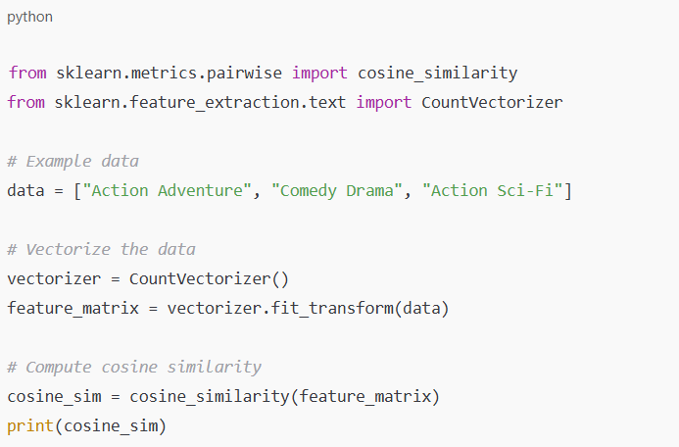

**CHAPTER 7**

**RESULTS**

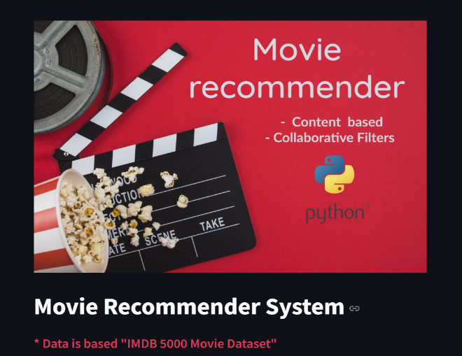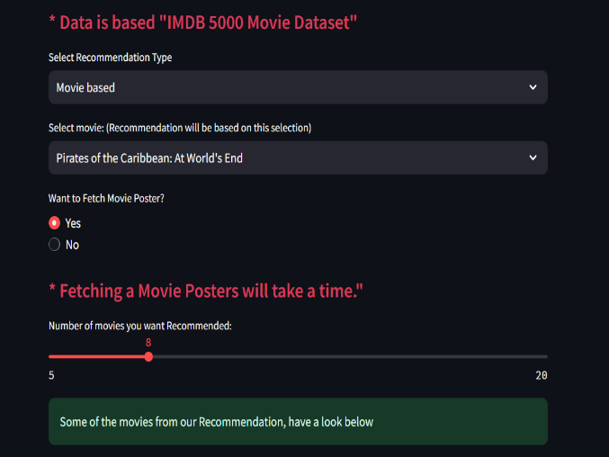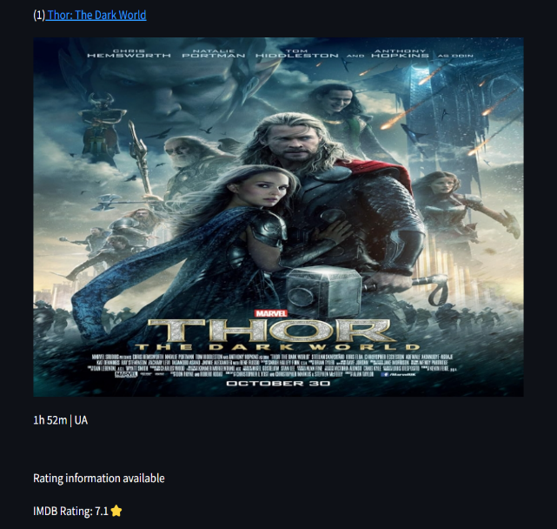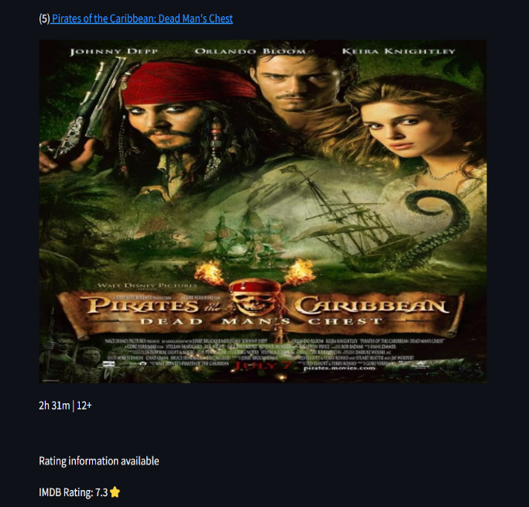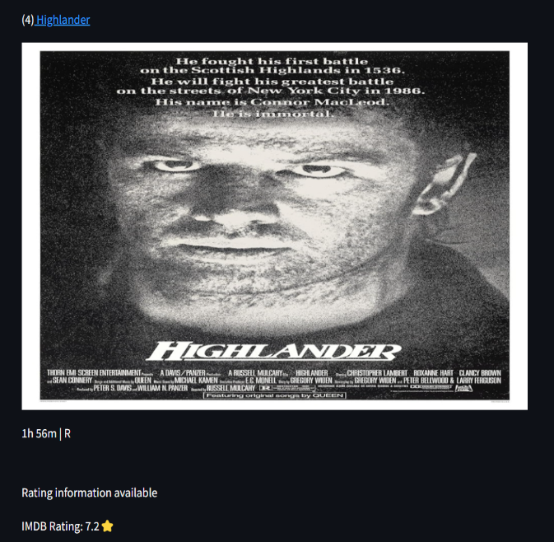

**REFERENCES**

**1.** Rujhan Singla, Samarth Gupta, Anirudh Gupta, Dinesh Kumar Vishwakarma, FLEX: A Content Based Movie Recommender, 978-1 7281-6221- 8/20/$31.00 ©2020 IEEE NLP

**2**. N. Kapoor, S. Vishal, and K. K. S., “Movie Recommendation System Using Tools,” IEEE Xplore, Jun. 01, 2020. https://ieeexplore.ieee.org/stamp/stamp.jsp?tp=&arnumber=9137993

**3.** S. Bhaskaran, R. Marappan, and B. Santhi, “Design and Analysis of a Cluster-Based Intelligent Hybrid Recommendation System for E Learning Applications,” Mathematics, vol. 9, no. 2, p. 197, Jan. 2021, doi: <https://doi.org/10.3390/math9020197>.

**4.** G. Vibhandik, “Movie Recommendation System using Machine Learning,” International Journal for Research in Applied Science and Engineering Technology, vol. 9, no. VI, pp. 4778 4781, Jun. 2021, doi: <https://doi.org/10.22214/ijraset.2021.35741>.

**5.** Y.-K. Ng, “MovRec: a personalized movie recommendation system for children based on online movie features,” International Journal of Web Information Systems, vol. 13, no. 4, pp. 445–470, Nov. 2017, doi: <https://doi.org/10.1108/ijwis-05-2017-0043>.

**6**. A. Yenkikar, N. Babu and S. Sangve, "R-SA: A Rule-based Expert System for Sentiment Analysis," 2019 IEEE Pune Section International Conference (PuneCon), Pune, India, 2019, pp. 1-7, doi: 10.1109/PuneCon46936.2019.9105682.

**7.** Pradnya Mehta, “Survey on movie rating and review summarization in mobile envioronment,” International Journal of Engineering Research and Technology, vol. 2, no. 3, 2017

**8.** A Nayan Varma and Kedareshwara Petluri, “Movie Recommender System using critic consensus,” Dec. 2021, doi: https://doi.org/10.1109/icac353642.2021.9697196.

**9.** A. Yenkikar and C. N. Babu, “AirBERT: A fine-tuned language representation model for airlines tweet sentiment analysis,” Intelligent Decision Technologies, vol. Preprint, no. Preprint, pp. 1–17, Jan. 2022, doi: https://doi.org/10.3233/IDT-220173.

**10.** J. Hemanth Duraisamy, A. Yenkikar, and N. Babu, “SENTINET: A DEEP SENTIMENT ANALYSIS NETWORK FOR POLITICAL MEDIA BIAS DETECTION,” DYNA, vol. 97, no. 6, pp. 645–651, Nov. 2022, doi: https://doi.org/10.6036/10593...

**11.** R. R. Patil and S. Kumar, "Rice Transformer: A Novel Integrated Management System for Controlling Rice Diseases," in IEEE Access, vol. 10, pp. 87698-87714, 2022, doi: 10.1109/ACCESS.2022.3200688.

**12.** R. Lavanya, U. Singh and V. Tyagi, "A Comprehensive Survey on Movie Recommendation Systems," 2021 International Conference on Artificial Intelligence and Smart Systems (ICAIS), 2021,pp.532- 536,doi:10.1109/ICAIS50930.2021.9395759.

**13.** Zhang, Jiang, et al. "Personalized real-time movie recommendation system: Practical prototype and evaluation." Tsinghua Science and Technology 25.2 (2019): 180-191.

**14.** Rajarajeswari, S., et al."Movie Recommendation System." Emerging Research in Computing, Information, Communication and Applications. Springer, Singapore, 2019. 329-340.